**KEEP ON ROLLIN’ GAME DESIGN DOCUMENT**

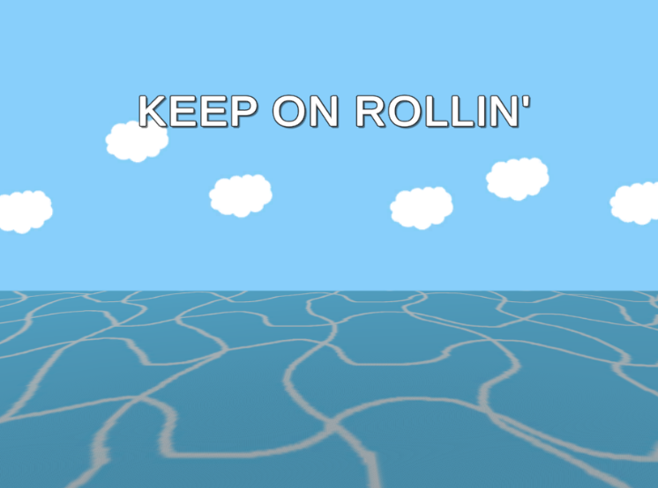

***‘Ball Is Life’*** – Huy Tran

This page: Table of Contents and Team Member Listing

|  |  |  |
| --- | --- | --- |
| Table of Contents  [1 Game Overview](https://n-xovwktmtjsnaxyc2mwes2xu7pohqedmdm6zjw5q-2lu-script.googleusercontent.com/userCodeAppPanel)  [2 High Concept](https://n-xovwktmtjsnaxyc2mwes2xu7pohqedmdm6zjw5q-2lu-script.googleusercontent.com/userCodeAppPanel)  [3 Unique Selling Points](https://n-xovwktmtjsnaxyc2mwes2xu7pohqedmdm6zjw5q-2lu-script.googleusercontent.com/userCodeAppPanel)  [4 Platform Minimum Requirements](https://n-xovwktmtjsnaxyc2mwes2xu7pohqedmdm6zjw5q-2lu-script.googleusercontent.com/userCodeAppPanel)  [5 Competitors / Similar Titles](https://n-xovwktmtjsnaxyc2mwes2xu7pohqedmdm6zjw5q-2lu-script.googleusercontent.com/userCodeAppPanel)  [6 Synopsis](https://n-xovwktmtjsnaxyc2mwes2xu7pohqedmdm6zjw5q-2lu-script.googleusercontent.com/userCodeAppPanel)  [7 Game Objectives](https://n-xovwktmtjsnaxyc2mwes2xu7pohqedmdm6zjw5q-2lu-script.googleusercontent.com/userCodeAppPanel)  [8 Game Rules](https://n-xovwktmtjsnaxyc2mwes2xu7pohqedmdm6zjw5q-2lu-script.googleusercontent.com/userCodeAppPanel)  [9 Game Structure](https://n-xovwktmtjsnaxyc2mwes2xu7pohqedmdm6zjw5q-2lu-script.googleusercontent.com/userCodeAppPanel)  [10 Game Play](https://n-xovwktmtjsnaxyc2mwes2xu7pohqedmdm6zjw5q-2lu-script.googleusercontent.com/userCodeAppPanel)  [10.1 Game Controls](https://n-xovwktmtjsnaxyc2mwes2xu7pohqedmdm6zjw5q-2lu-script.googleusercontent.com/userCodeAppPanel)  [10.2 Game Camera](https://n-xovwktmtjsnaxyc2mwes2xu7pohqedmdm6zjw5q-2lu-script.googleusercontent.com/userCodeAppPanel)  [10.2.1 HUD](https://n-xovwktmtjsnaxyc2mwes2xu7pohqedmdm6zjw5q-2lu-script.googleusercontent.com/userCodeAppPanel)  [10.2.2 Maps](https://n-xovwktmtjsnaxyc2mwes2xu7pohqedmdm6zjw5q-2lu-script.googleusercontent.com/userCodeAppPanel)  [11 Players](https://n-xovwktmtjsnaxyc2mwes2xu7pohqedmdm6zjw5q-2lu-script.googleusercontent.com/userCodeAppPanel)  [11.1 Characters](https://n-xovwktmtjsnaxyc2mwes2xu7pohqedmdm6zjw5q-2lu-script.googleusercontent.com/userCodeAppPanel)  [11.2 Metrics](https://n-xovwktmtjsnaxyc2mwes2xu7pohqedmdm6zjw5q-2lu-script.googleusercontent.com/userCodeAppPanel)  [11.3 States](https://n-xovwktmtjsnaxyc2mwes2xu7pohqedmdm6zjw5q-2lu-script.googleusercontent.com/userCodeAppPanel)  [11.4 Weapons](https://n-xovwktmtjsnaxyc2mwes2xu7pohqedmdm6zjw5q-2lu-script.googleusercontent.com/userCodeAppPanel)  [12 Player Line-up](https://n-xovwktmtjsnaxyc2mwes2xu7pohqedmdm6zjw5q-2lu-script.googleusercontent.com/userCodeAppPanel)  [13 NPC](https://n-xovwktmtjsnaxyc2mwes2xu7pohqedmdm6zjw5q-2lu-script.googleusercontent.com/userCodeAppPanel)  [13.1 Enemies](https://n-xovwktmtjsnaxyc2mwes2xu7pohqedmdm6zjw5q-2lu-script.googleusercontent.com/userCodeAppPanel)  [13.1.1 Enemy States](https://n-xovwktmtjsnaxyc2mwes2xu7pohqedmdm6zjw5q-2lu-script.googleusercontent.com/userCodeAppPanel)  [13.1.2 Enemy Spawn Points](https://n-xovwktmtjsnaxyc2mwes2xu7pohqedmdm6zjw5q-2lu-script.googleusercontent.com/userCodeAppPanel)  [13.2 Allies / Companions](https://n-xovwktmtjsnaxyc2mwes2xu7pohqedmdm6zjw5q-2lu-script.googleusercontent.com/userCodeAppPanel)  [13.2.1 Ally States](https://n-xovwktmtjsnaxyc2mwes2xu7pohqedmdm6zjw5q-2lu-script.googleusercontent.com/userCodeAppPanel)  [13.2.2 Ally Spawn Points](https://n-xovwktmtjsnaxyc2mwes2xu7pohqedmdm6zjw5q-2lu-script.googleusercontent.com/userCodeAppPanel)  [14 Art](https://n-xovwktmtjsnaxyc2mwes2xu7pohqedmdm6zjw5q-2lu-script.googleusercontent.com/userCodeAppPanel)  [14.1 Setting](https://n-xovwktmtjsnaxyc2mwes2xu7pohqedmdm6zjw5q-2lu-script.googleusercontent.com/userCodeAppPanel)  [14.2 Level Design](https://n-xovwktmtjsnaxyc2mwes2xu7pohqedmdm6zjw5q-2lu-script.googleusercontent.com/userCodeAppPanel)  [14.3 Audio](https://n-xovwktmtjsnaxyc2mwes2xu7pohqedmdm6zjw5q-2lu-script.googleusercontent.com/userCodeAppPanel)  [15 Procedurally Generated Content](https://n-xovwktmtjsnaxyc2mwes2xu7pohqedmdm6zjw5q-2lu-script.googleusercontent.com/userCodeAppPanel)  [15.1 Environment](https://n-xovwktmtjsnaxyc2mwes2xu7pohqedmdm6zjw5q-2lu-script.googleusercontent.com/userCodeAppPanel)  [15.2 Levels](https://n-xovwktmtjsnaxyc2mwes2xu7pohqedmdm6zjw5q-2lu-script.googleusercontent.com/userCodeAppPanel)  [15.3 Artificial Intelligence NPC](https://n-xovwktmtjsnaxyc2mwes2xu7pohqedmdm6zjw5q-2lu-script.googleusercontent.com/userCodeAppPanel)  [15.4 Visual Arts](https://n-xovwktmtjsnaxyc2mwes2xu7pohqedmdm6zjw5q-2lu-script.googleusercontent.com/userCodeAppPanel)  [15.5 Audio](https://n-xovwktmtjsnaxyc2mwes2xu7pohqedmdm6zjw5q-2lu-script.googleusercontent.com/userCodeAppPanel)  [15.6 Minimum Viable Product (MVP)](https://n-xovwktmtjsnaxyc2mwes2xu7pohqedmdm6zjw5q-2lu-script.googleusercontent.com/userCodeAppPanel)  [16 Wish List](https://n-xovwktmtjsnaxyc2mwes2xu7pohqedmdm6zjw5q-2lu-script.googleusercontent.com/userCodeAppPanel)   |  | | --- | |  | | Game Development Team Members    PRODUCER  Huy Tran    PRODUCTION MANAGER  Huy Tran    PRODUCTION COORDINATOR  Huy Tran  GAME DESIGNERS  Huy Tran  SYSTEMS/IT COORDINATOR  Huy Tran  PROGRAMMERS  Huy Tran  TECHNICAL ARTISTS  Huy Tran  AUDIO ENGINEERS  Huy Tran  UX TESTERS  Huy Tran |

|  |
| --- |
|  |

# 1 Game Overview

Title: Keep On Rollin’

Platform: PC Standalone

Genre: 3D Platformer

Rating: (10+) ESRB

Target: Casual gamer (aging from 12 - 30)

Release date: May, 2020

Publisher: Huy Tran

Keep On Rollin’ is a 3D platformer where the Player is a ball that can roll around the track floating above the sea. The player must collect all the Gems in the track within the time limit. There is an achievement system where the Player can find and collect up to three Stars in the map to make the game more challenging.

# 2 High Concept

Keep On Rollin’ sets the Player on a track that floats above the sea where the Player can roll around the track freely. The Player has to collect all the Gems in the track before time runs out. If the Player step onto a Speed boost platform, it will give the Player a boost in speed. It can help the Player get to places that cannot normally be done with normal speed. If the Player falls into the sea, they will respawn back at the original position after two seconds. To make the game more challenging, there are three Stars in each level that the Player can collect as achievement. They are typically at locations that are hard to get to.

# 3 Unique Selling Points

* Compatible with Windows and Mac OS X
* Unique and minimalist artwork
* Simple yet engaging gameplay
* Players can compete with each other

# 4 Platform Minimum Requirements

PC, MAC STANDALONE

OS: Windows XP SP2+, Mac OS X 10.0+

Graphics card: DX9 (shader model 2.0) capabilities; generally everything made since 2004 should work

# 5 Competitors / Similar Titles

* Super Monkey Ball by Sega
* Roll-a-ball by Unity Technologies

# 6 Synopsis

You are a ball wandering around, exploring places. Somehow, you ended up at a place, floating above the sea. This place is full of Gems for you to collect. Is that not enough for you? Is that too easy? Be the one to collect the stars that no one else can.

# 7 Game Objectives

The objective is to collect all the gems within the time limit. There are also three Stars in each level and the player can collect those as an achievement to show how good they are.

# 8 Game Rules

The game levels are set on a track that floats above the sea. The Player will start at the beginning of the track and can roll freely anywhere on the track to collect the Gems and Stars. If they fall into the sea, they will respawn back at the beginning after two seconds. The player will lose when the timer reaches zero. The Speed boost platforms are there to help the Player goes faster or jump higher to get to places as needed.

# 9 Game Structure

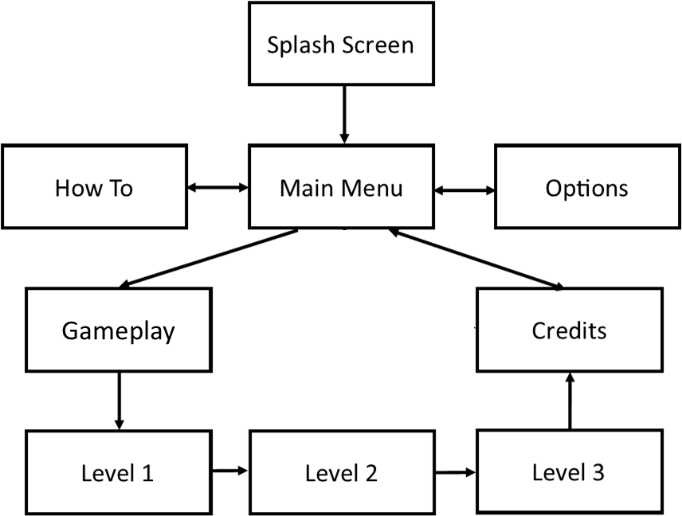

# 10 Game Play

## 10.1 Game Controls (PC)

**MOVE PAUSE**

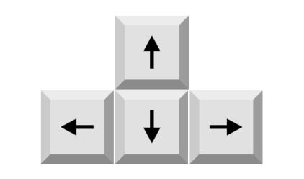

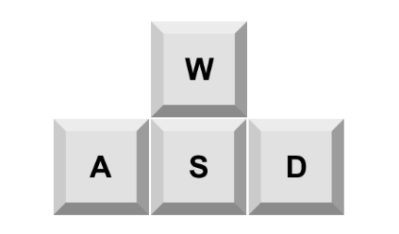



**or**

**or**

## 10.2 Game Camera

The game has a third person point of view. The camera will always look at and follow the Player from a fixed offset distance. When the Player rotates left or right, the camera will rotate also. The Player will always appear to be in the middle of the screen.

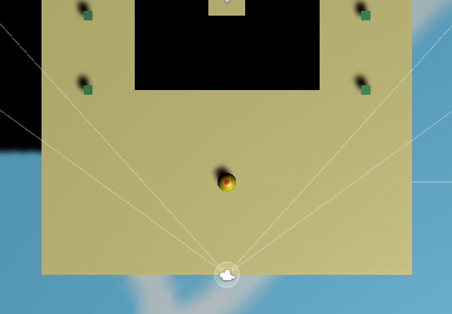 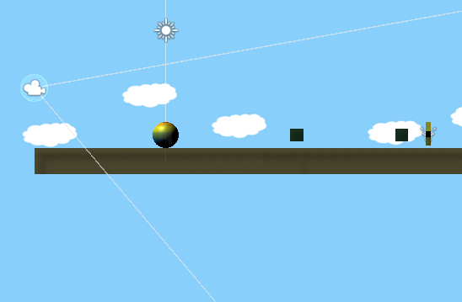

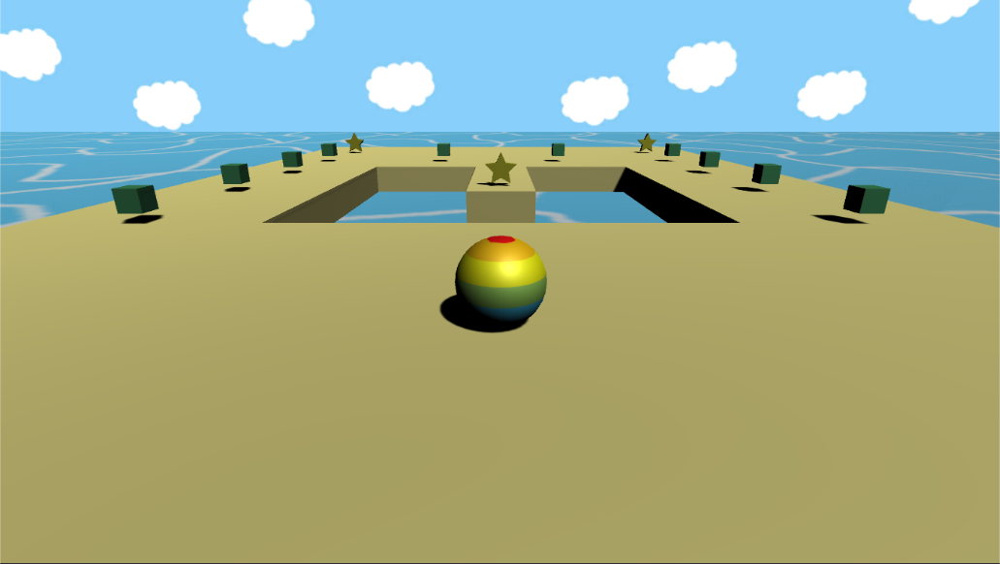

### 10.2.1 HUD

GEMS DISPLAY

First row of the top left corner shows the number of Gems (X/Y). X is the number of Gems that the Player has collected, and Y is the number of Gems available. X has to be equal to Y in order to win the game.

STAR DISPLAY

Second row of the top left corner shows the number of Stars that the Play has collected. There are three stars to be collected in each level. Yellow shows the number collected, and gray shows not collected.

TIMER

Top center shows the timer that will start counting down after the game starts (after the Start countdown 3, 2, 1, Go!). When the timer reaches zero, the Player will lose and a game over menu will show up.

### 

### 10.2.2 Maps

There are three levels in the game. Each level has a separate map or track. Each track is designed with an increase in difficulty in the aspects that there are more Gems to be collected, stars at locations that are harder to get to, smaller platforms that are put in ways to make it harder to move. Level 1 is the easiest and level 3 is the hardest.

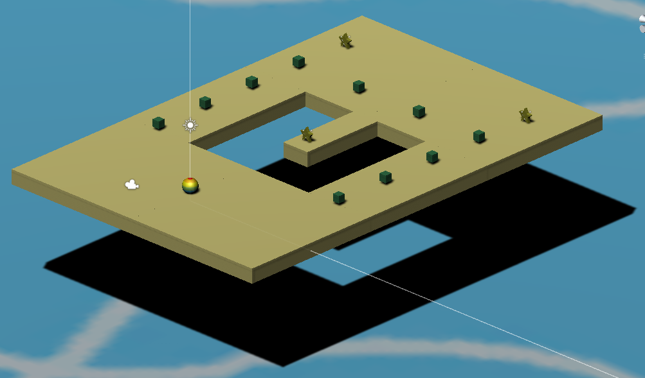

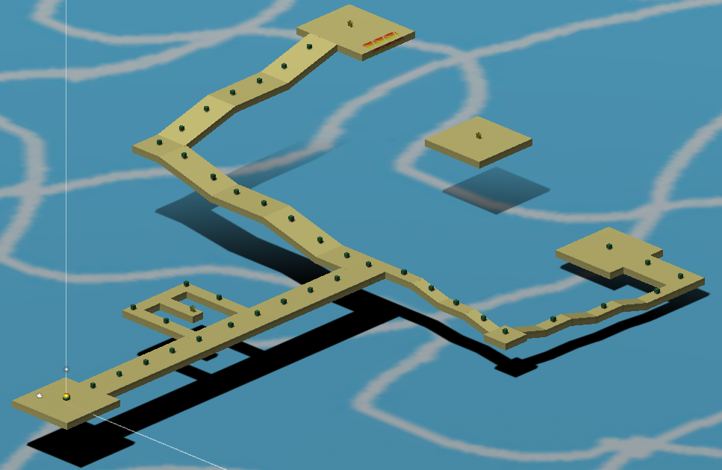

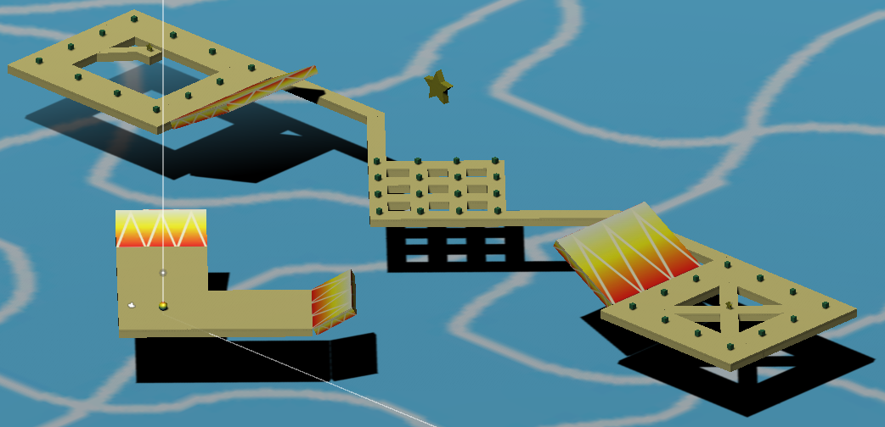

# 11 Players

## 11.1 Characters

The player is controlling a ball that can roll around the track

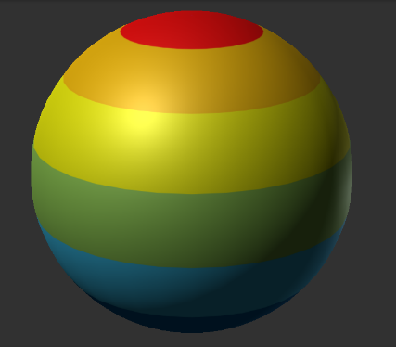

## 11.2 Metrics

Diameter: 1 m

Speed: 1000

## 11.3 States

**Idle:** The ball just stay still with no animation

**Move:** Input from the ARROW keys or WASD keys will cause force to be applied onto the ball to make it move by rolling.

**Death:** When the ball falls into the sea, it will respawn at the beginning position. The ball will appear and be dropped onto the platform

## 11.4 Weapons

N/A

# 12 Player Line-up

N/A

# 13 NPC

## 13.1 Enemies

N/A

### 13.1.1 Enemy States

N/A

### 13.1.2 Enemy Spawn Points

N/A

## 13.2 Allies / Companions

N/A

### 13.2.1 Ally States

N/A

### 13.2.2 Ally Spawn Points

N/A

# 14 Art

## 14.1 Setting

The game takes place outside, in an open landscape above the sea. When standing on the platform, the player can see the sea and the sky with clouds and the sun.

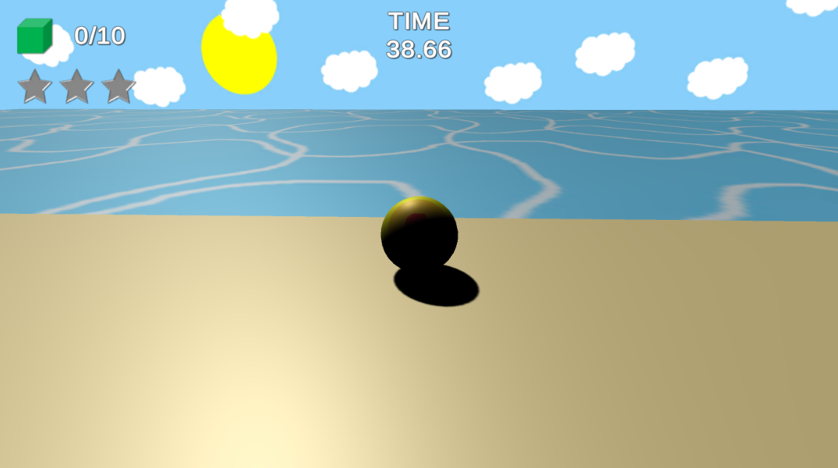

## 14.2 Level Design

The level consists of the platforms to build to the track, with Gems and Stars dispersed around the track. Speed boost platforms are placed in locations that are necessary for the Player to get certain places as needed. The Player will always respawn in the same location which is the starting position (bottom center in the track below)

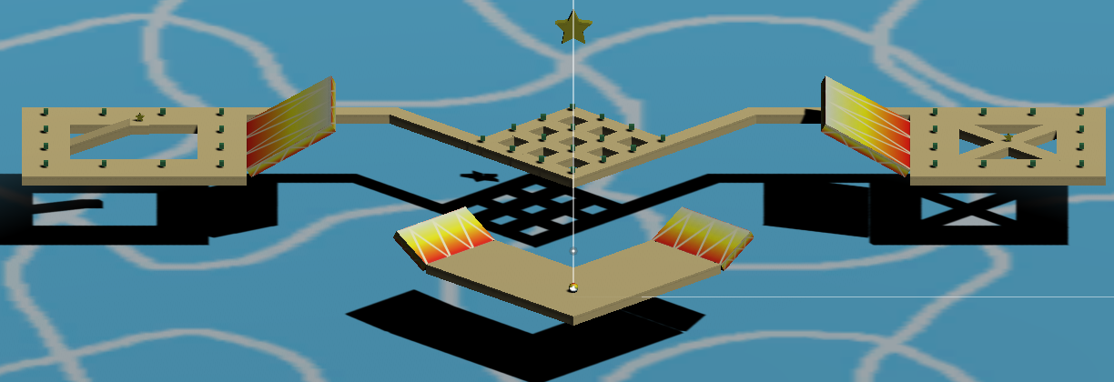

## 14.3 Audio

|  |  |  |
| --- | --- | --- |
| NAME | CATEGORY | DESCRIPTION |
| Beach Town Guitar Theme | Background music | Plays and loops throughout the game |
| Gem | FX | When the player collect a gem |
| Lose | FX | When the timer runs out |
| Star | FX | When the player collect a star |
| Start Countdown (3, 2, 1, Go!) | FX | Start countdown at the beginning of scene |
| Water Splash | FX | When the player falls into the sea |
| Win | FX | When the player collects all the gem |

# 15 Procedurally Generated Content

## 15.1 Environment

N/A

## 15.2 Levels

N/A

## 15.3 Artificial Intelligence NPC

N/A

## 15.4 Visual Arts

The Gems and Stars float above the platforms and continuously rotate throughout the game. The Stars glow and emit yellow particles from them. The particles are created using Unity particle system.

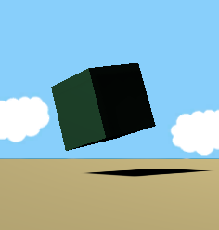 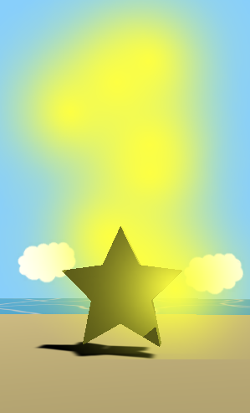

## 15.5 Audio

* Background music is played and loops throughout the game
* Sound Effects (mentioned in Section 14.3) are played when the corresponding actions happen

## 15.6 Minimum Viable Product (MVP)

* Built for the PC platform (Windows and Mac OS X)
* Collectible Gems and Stars
* Lose when timer runs out
* Platforms to move on
* Speed boost platform to boost the player’s speed
* Player respawns at the original position when fall into the sea
* One Player character
* Background music that plays and loops throughout the game
* Have a star achievement system

# 16 Wish List

* Fix the ball’s physics
  + Sometimes the ball jumps up randomly
* Add animation to the sea and water splash
* Add more ball designs for the player to choose from
* Add more levels
* Add other obstacles that could affect the difficulty of the game